**Project Design Phase-II**

**Data Flow Diagram & User Stories**

|  |  |
| --- | --- |
| Date | 03 October 2023 |
| Team ID | NM2023TMID05023 |
| Project Name | A COMPARATIVE STUDY OF TOP GLOBAL UNIVERSITIES IN DATA ANALYTICS |
| Maximum Marks | 4 Marks |

**Data Flow Diagrams:**

A Data Flow Diagram (DFD) is a traditional visual representation of the information flows within a system. A neat and clear DFD can depict the right amount of the system requirement graphically. It shows how data enters and leaves the system, what changes the information, and where data is stored.

**Data flow diagram :**

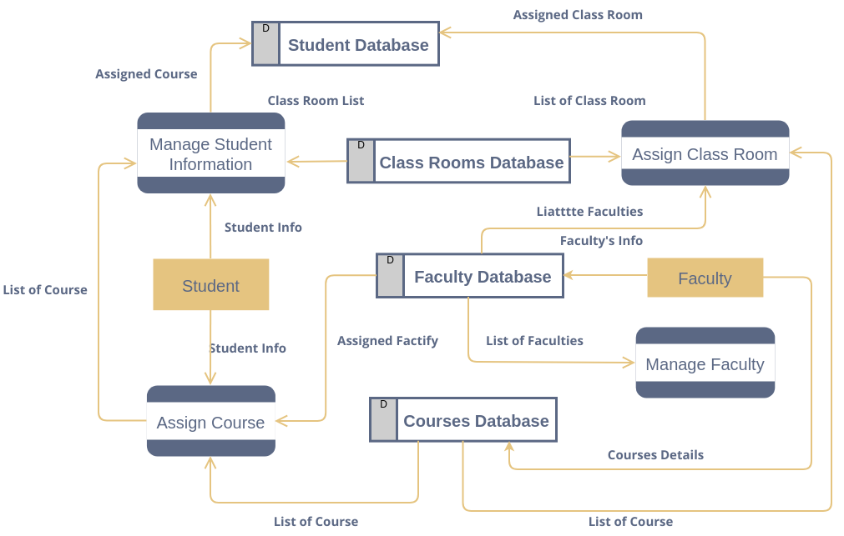

**User Stories**

Use the below template to list all the user stories for the product.

|  |  |  |  |  |  |  |
| --- | --- | --- | --- | --- | --- | --- |
| **User Type** | **Functional**  **Requirement (Epic)** | **User Story**  **Number** | **User Story / Task** | **Acceptance criteria** | **Priority** | **Release** |
| Data Analyst | Data analysis capabilities | USN-1 | As a Data Analyst, I want to access IBM Cognos Analytics to perform data analysis for campaign success. | - Log in to IBM Cognos Analytics. - Import marketing campaign data. - Analize data to identify trends and insights. | High | Sprint-1 |
| Data analyst | Data visualization | USN-2 | As a Data Analyst, I want to create data visualizations in IBM Cognos Analytics for marketing campaigns | - Access data in IBM Db2. - Create informative visualizations. - Customize dashboards | High | Sprint-1 |
| IT specialist | Data security and integration | USN-3 | As an IT Specialist, I want to ensure data security and smooth integration of IBM Cognos Analytics with IBM Db2. | - Configure secure data access. - Monitor data integration. - Implement data security measures. | Low | Sprint-2 |
| Team leader | Project Coordinator | USN-4 | As a Team leader, I want to coordinate the efforts of the team to implement data analysis for top universities successfully. | - Define project milestones. - Coordinate data analysis tasks. - Monitor project progress. | Medium | Sprint-1 |
| CEO/Management | Alignment and goals | USN-5 | As CEO/Management, we want to ensure that data analysis aligns with our channel goals and supports informed decision-making. | - Review data analysis strategy. - Assess the alignment with goals. - Support strategic decisions | High | Sprint-1 |
| Data visualization | Dashboard | USN-6 | The top universities in the world to visit the customers or students | -Review the world map of the top universities | High | Sprint-2 |